**Workforce Administration**

***Case Study 1:***

Transactions to be performed are - *Home Address change, Change in Department, Employee on Paid Leave, Employee Return from Paid Leave, Terminating the Employee and Rehire the same Employee*

Make sure the below transaction satisfies all the conditions mentioned with respect to Effective Date and Action, Action Reasons:

1. **Personal Data Change** - In a Modify a Person page in Correct History Mode, change the Home Address details of an employee and save the page
2. **Department Change** - In Job Page, add a new row with effective date using Correct History Mode, with Action 'Data Change' and Action Reason 'Correction - Department' and change the Department to new value and save
3. **Employee on Paid Leave** - In Job Page, add a new row with effective date using Correct History Mode, with Action 'Paid Leave of Absence' with some Action Reason and save the page
4. **Employee Return from Paid Leave** - In Job Page, add a new row with effective date using Correct History Mode, with Action 'Return from Leave' with some Action Reason and save the page
5. **Employee Termination** - Add a new row with current effective date 'SYSDATE' (Today's Date) using Correct History Mode, with Action 'Termination' and Action Reason 'Misconduct' and save the page
6. **Rehire** - Add a new row in JOB Data with future Effective Date with Action - Rehire and Action Reason - Rehire and save the page

**Step by Step Procedure:**

**a. Personal Data Change - In a Modify a Person page in Correct History Mode, change the Home Address details of an employee and save the page**

**Step 1:** Navigate to ‘Modify a Person’ page with the below navigation,

* Navigation: Workforce Administration -> Personal Information -> Biographical -> Modify a Person

**Step 2:** Provide the employee id in the ‘Emplid’ field and click Search

**Step 3:** The User should be navigated to employee’s Modify a Person page

**Step 4:** Select the checkbox for ‘Correct History’ at the bottom of the page

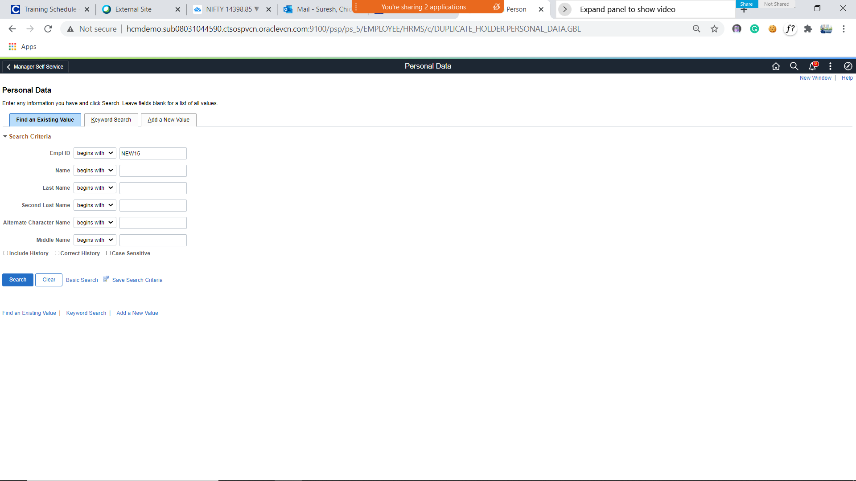

**Step 5:** Under ‘Biographical tab’, click the Address details tab

**Step 6:** Click ‘Update’ icon of existing address details and modify the Home Address details and click Ok

**Step 7:** The new Home Address details should be populated

**Step 8:** Click ‘Save’ and verify the employee Personal Information is updated successfully with the new Home Address details

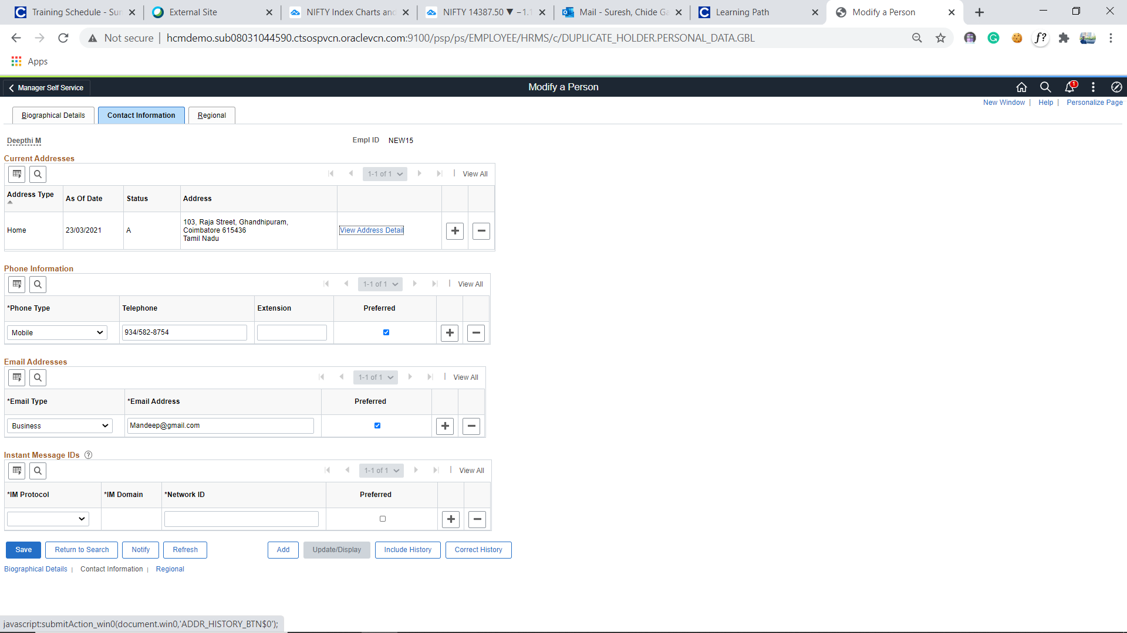

**b. Department Change - In Job Page, add a new row using Correct History Mode,** **with Action 'Data Change' and Action Reason 'Correction - Department' and change the Department to new value and save**

**Step 1:** Navigate to ‘Job Data’ page with the below navigation,

* Navigation: Workforce Administration -> Job Information -> Job Data

**Step 2:** Provide the employee ID in the ‘Empl ID’ field

**Step 3:** Click ‘Search’

**Step 4:** Verify the search is navigated to employee’s Job Data page

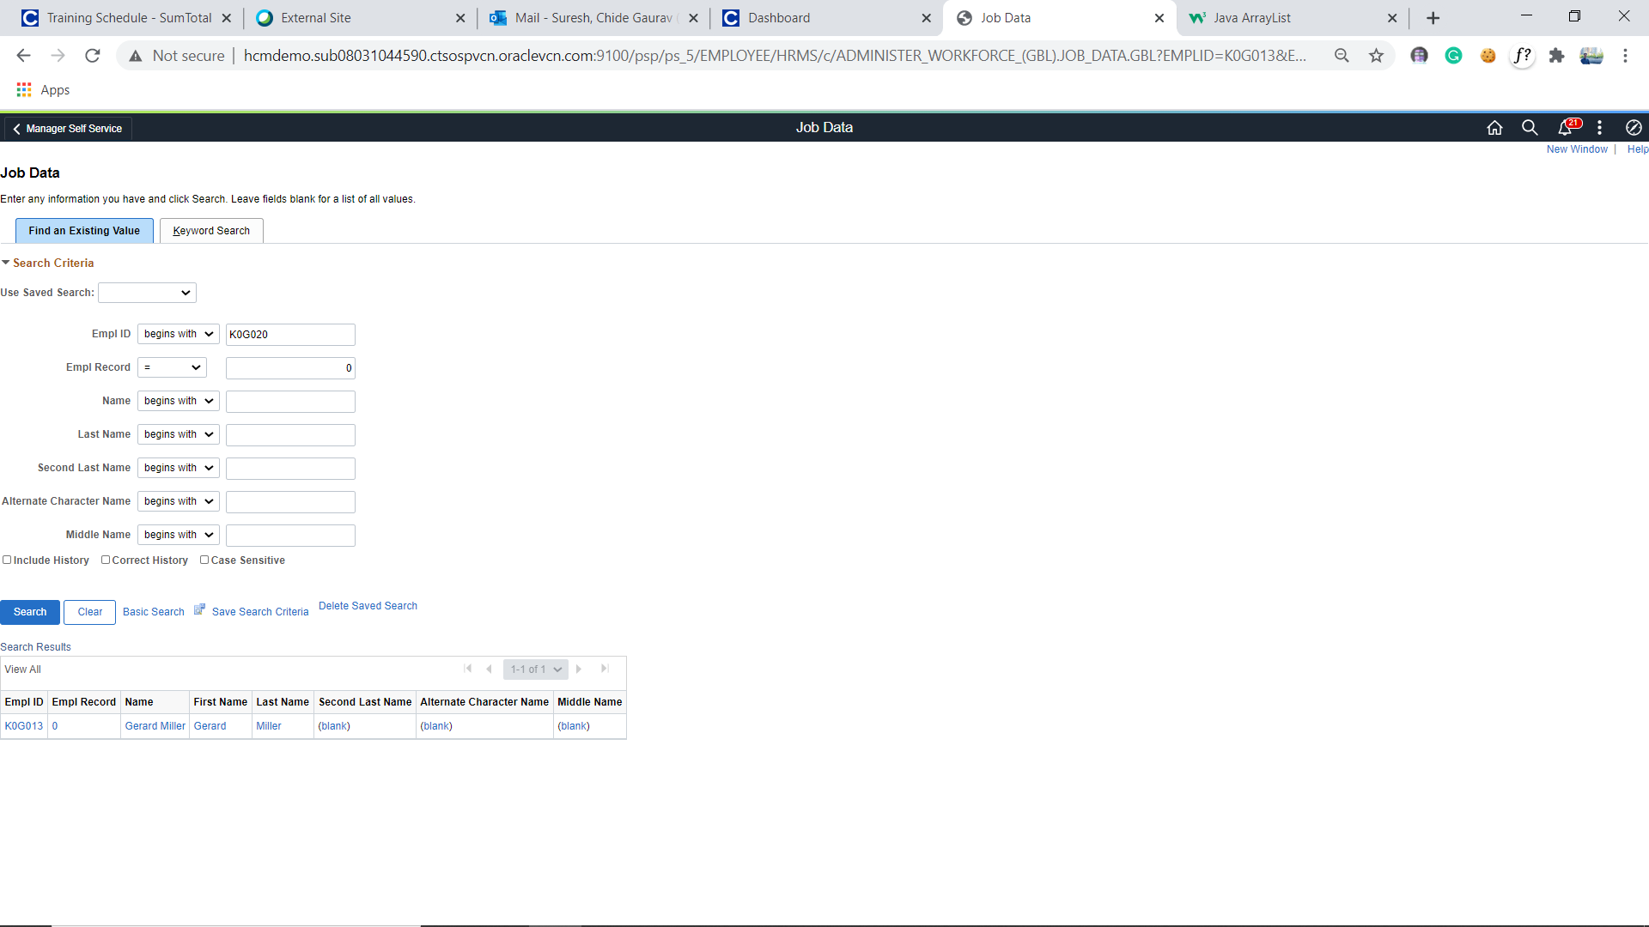

**Step 5:** Check ‘Correct History’ and click ‘+’ icon under the Job Data page and verify a new row is added under the Work Location tab

**Step 6:** Select the Effective date = 04/05/2021 and Action = ‘Data Change’ and Action Reason = 'Correction – Department’

**Step 7:** Update the ‘Dept ID’ code to any other existing Department id from the prompt

**Step 8:** Click ‘Save’ and verify a new row with Effective Date as 04/05/2021 is added and new Dept ID is updated

**Step 9:** Verify the ‘Payroll Status’ & ‘HR Status’ is Active

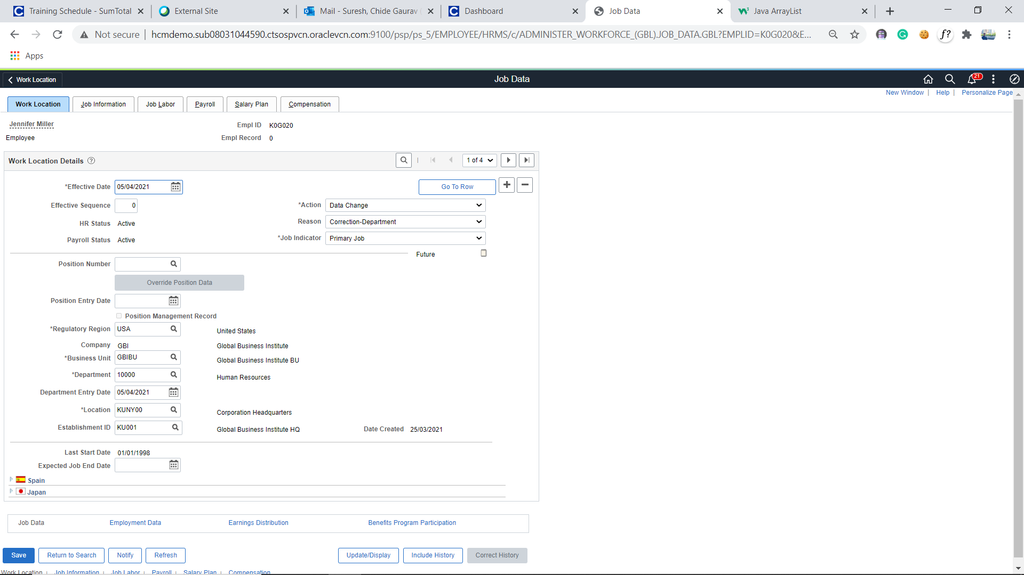

**c. Employee on Paid Leave - In Job Page, add a new row with effective date using Correct History Mode,** **with Action 'Paid Leave of Absence' with some Action Reason and save the page**

**Step 1:** Navigate to ‘Job Data’ page with the below navigation,

* Navigation: Workforce Administration -> Job Information -> Job Data

**Step 2:** Provide the employee ID in the ‘Emplid’ field

**Step 3:** Click ‘Search’

**Step 4:** Verify the search is navigated to employee’s Job Data page

**Step 5:** Check ‘Correct History’ and click ‘+’ icon under the Job Data page and verify a new row is added under the Work Location tab

**Step 6:** Select the Effective date = and Action = ‘Paid Leave of Absence’ and select any Action Reason value

**Step 7:** Click ‘Save’ and verify a new row with Effective Date as with Action ‘Paid Leave of Absence’ is added successfully

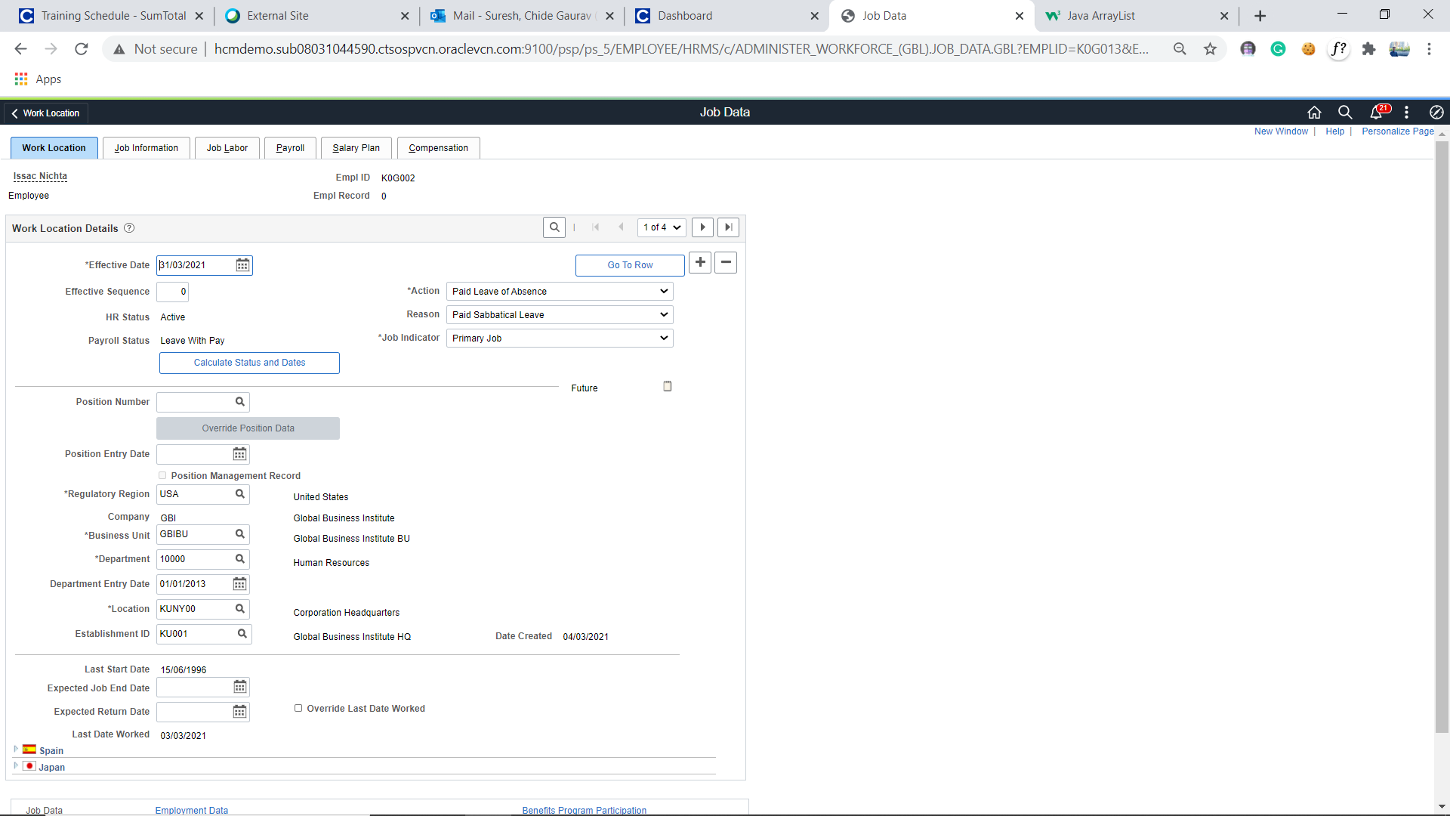

**d. Employee Return from Paid Leave - In Job Page, add a new row with effective date using Correct History Mode, with Action 'Return from Leave' with some Action Reason and save the page**

**Step 1:** Navigate to ‘Job Data’ page with the below navigation,

* Navigation: Workforce Administration -> Job Information -> Job Data

**Step 2:** Provide the employee ID in the ‘Emplid’ field

**Step 3:** Click ‘Search’

**Step 4:** Verify the search is navigated to employee’s Job Data page

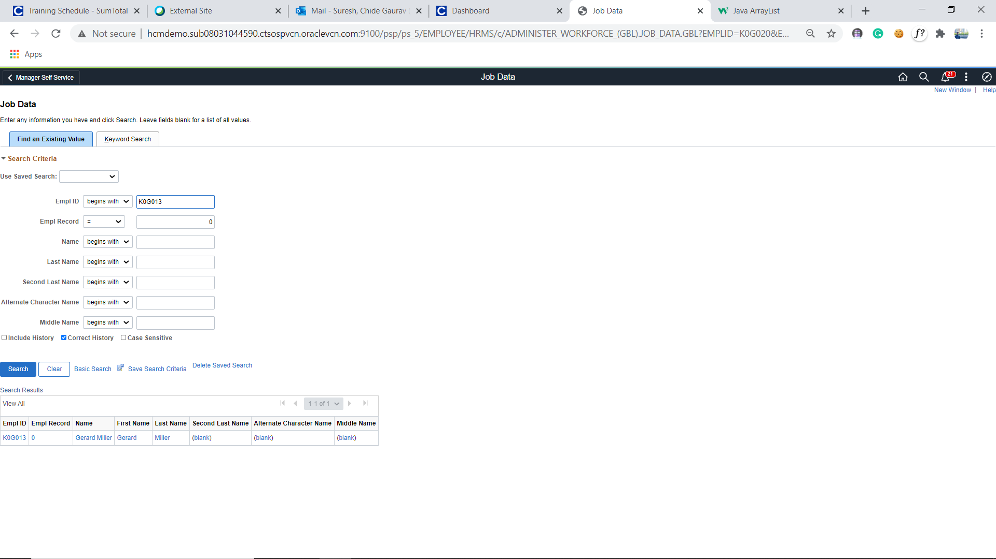

**Step 5:** Check ‘Correct History’ and click ‘+’ icon under the Job Data page and verify a new row is added under the Work Location tab

**Step 6:** Select the Effective date and Action = ‘Return from Leave’ and select any Action Reason value

**Step 7:** Click ‘Save’ and verify a new row with Effective Date as with Action as ‘Return from Leave’ is added successfully

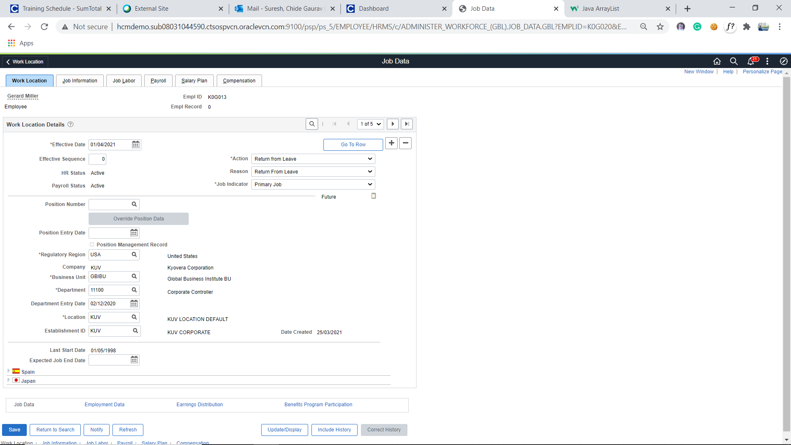

**e. Employee Termination - Add a new row with current effective date 'SYSDATE' (Today's Date) using Correct History Mode, with Action 'Termination' and Action Reason 'Misconduct' and save the page**

**Step 1:** Navigate to ‘Job Data’ page with the below navigation,

* Navigation: Workforce Administration -> Job Information -> Job Data

**Step 2:** Provide the employee ID created via ‘Add a Person’ page in the ‘Emplid’ field

**Step 3:** Click ‘Search’

**Step 4:** Verify the search is navigated to employee’s Job Data page

**Step 5:** Check ‘Correct History’ and click ‘+’ icon under the Job Data page and verify a new row is added under the Work Location tab

**Step 6:** Select the Effective date = SYSDATE and Action = ‘Termination’ and Action Reason = ‘Misconduct’

**Step 7:** Click ‘Save’ and verify a new row with Effective Date as SYSDATE with Action as ‘Termination’ is added successfully

**Step 8:** Verify the Payroll Status is updated as ‘Terminated’ and HR Status as ‘Inactive’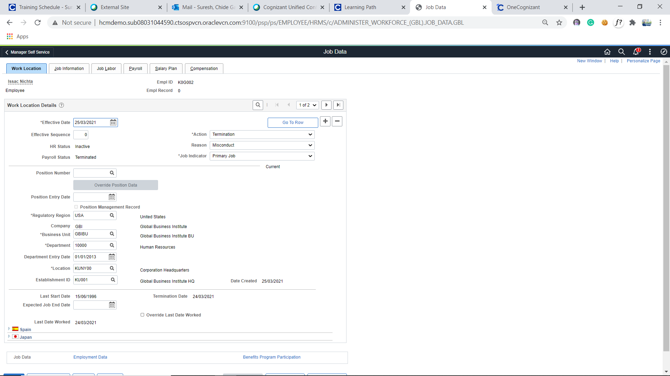

**f. Rehire - Add a new row in JOB Data with future Effective Date with Action - Rehire and Action Reason - Rehire and save the page**

**Step 1:** Navigate to ‘Job Data’ page with the below navigation,

* Navigation: Workforce Administration -> Job Information -> Job Data

**Step 2:** Provide the employee ID created via ‘Add a Person’ page in the ‘Emplid’ field

**Step 3:** Click ‘Search’

**Step 4:** Verify the search is navigated to employee’s Job Data page

**Step 5:** Check ‘Correct History’ and click ‘+’ icon under the Job Data page and verify a new row is added under the Work Location tab

**Step 6:** Select the Effective date = Future date and Action = ‘Rehire’ and Action Reason = ‘Rehire’

**Step 7:** Click ‘Save’ and verify a new row with Effective Date as Future dated with Action as ‘Rehire’ is added successfully

**Step 8:** Verify the ‘Payroll Status’ & ‘HR Status’ is updated as ‘Active’

